TASK #1

1. My laptop private IP address is: 169.254.97.112
2. HOST A IP address is: 172.31.45.33
3. HOST B IP address is: 172.31.38.47

TASK #2

1. Before running SimpleClient on my latop, it shows nothing

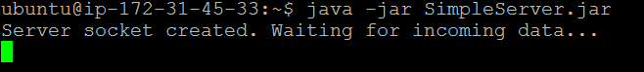

1. After running Simple Client on my laptop, it shows as below, printing out public IP and PORT of my laptop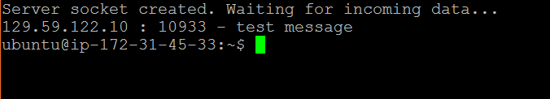

TASK # 3

1. After running SimpleServer on HOST A, it print out the IP and PORT of HOST A

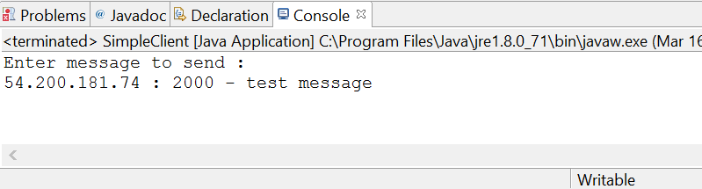

Task #4

1. The source IP address is 129.59.122.10, but port is changing each time.

It is same as my laptop’s local IP address.

1. Public IP address of NAT gateway of my laptop is 129.59.122.10.

TASK #5

1. After running Server on HOST A, and Client on HOST B, we can see command like below:

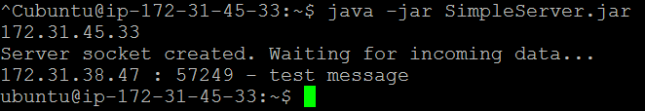

The source IP addr and port HOST A saw is 172.31.38.47, 57249 seperately.

1. Public IP addr of NAT gateway of HOST B is 54.186.216.253

TASK #6